LAB # 8
Generics in Java
OBJECTIVE:
Implementing generic classes and methods for ensuring compile time type safety of data.
TASK: 1
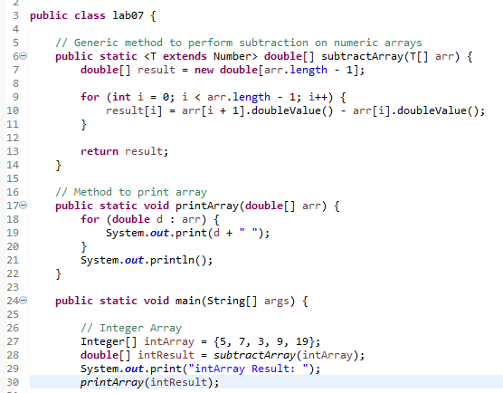
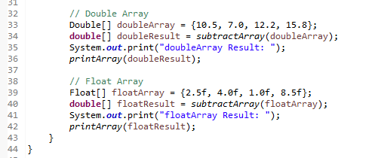
OUTPUT
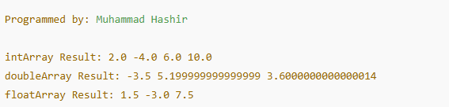

GITHUB SCREENSHOT :



